Hello Teacher and Students!
We wanted to let you know that when you log in to the Pearson Saskatchewan Portal, you will notice that your eTexts look different this year. This is Pearson’s new eText player, that’s been designed specifically without the use Flash.
What’s The Same?
- The login page
- The bookshelf
- The books
- The content and media in the books
- The Teacher role (in some books, teachers see different content than students)
What’s New?
- The eText no longer requires Flash to open
- New App: Pearson has a new eText app for mobile devices! The previous “eText for Canada” app is still available and can continue to be used, if you wish. The new app is compatible with Smartphones, which the previous app is not.
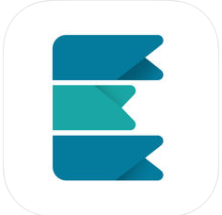
- Table of Contents: click the drop-down menu in the top left corner to open the table of contents and folders containing the media and other resources. As well, this is the place where you find the notes and bookmarks that you create.
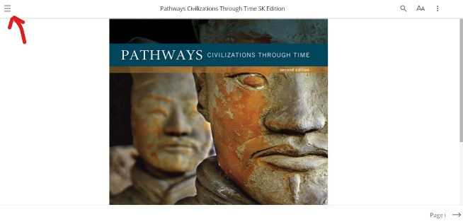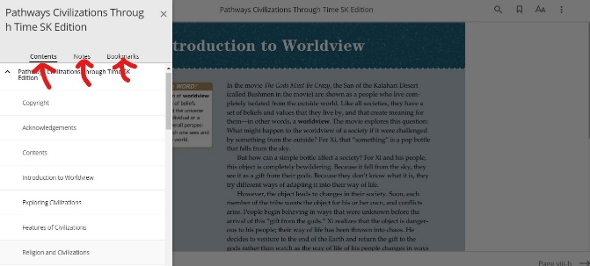

- Navigation: Turn the pages using the arrow in the bottom right corner. Jump to a specific page by using the magnifying glass icon (Search) in the top right corner.
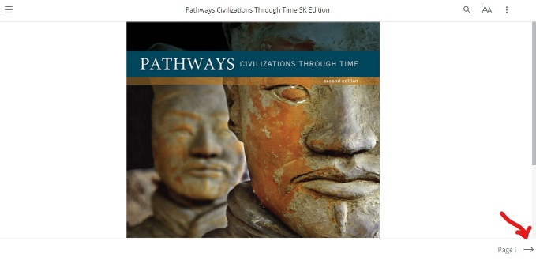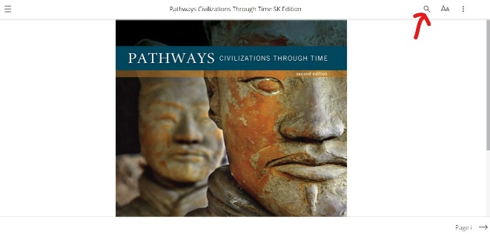
- Notes/Highlights: To highlight and/or write a note, use your mouse to highlight a passage of text, and then choose a colour option for the highlight and write your note.
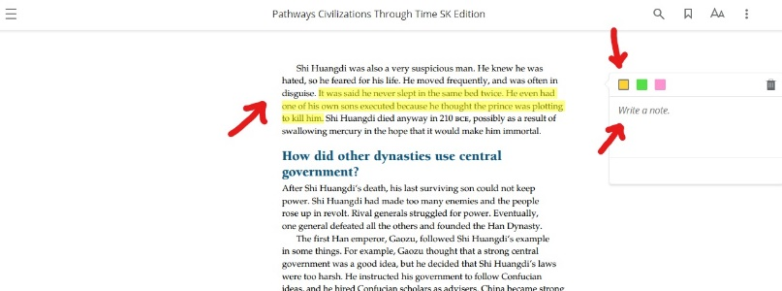
- The Bookmark icon and the Change Text Size icon are both in top right corner.
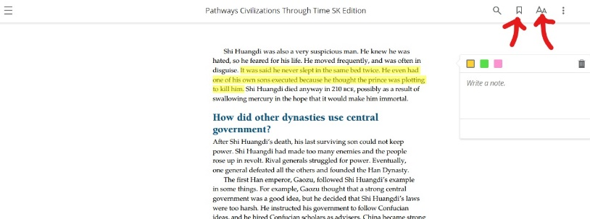
What’s Coming Next?
- Double-page spread view (October 2018)
- The Back-to-Bookshelf button (October 2018). Until this button is activated, please use the BACK button on your browser to get back to the bookshelf.

We hope that you have a great learning experience using the new eTexts! For questions or help, please reach out to Pearson through skpsupport@pearsoncanada.com.

