UNIT
19 | Telephone  Techniques and Services

Review Questions

PART A
Complete the following sentences by filling in the blanks.
- In making a long-distance call, ____________________ dialling is less expensive than making an operator-assisted call.
- When the recipient pays for the call, it is a/an ____________________ call.
- For overseas inquiries, dial ____________________ and ask the operator for assistance.
- The three digits used to identify major parts of Canada and the United States for telephone call routing are known as the ____________________.
- When a call is switched from one person to another, the call is said to have been ____________________.
- The ____________________ button enables the receiving operator to accept another incoming call without cutting off the first caller.
- In ____________________-to-____________________ calling, the charge begins when the called telephone is picked up.
- ____________________ store or produce telephone numbers to be called and deliver either a pre-recorded or synthesized voice message..
- A/an ____________________ call enables several people in different locations to have a meeting by telephone.
- To find the new telephone number of a company that has just moved to Winnipeg, you would dial 1+ 204 + ____________________.
- ____________________ service is available to companies that want to encourage customers to call long distance toll-free from a specified wide area.
- You would look in the ____________________ directory to find local courier services.
- If you wanted to find telephone numbers of government departments you would look in the ____________________.
- In-house telephone directories may be a list, card index file, indexed container, or ____________________.
- An electronic ____________________ switchboard usually handles only incoming calls.
- A large central switchboard in one location that has its own exchange number is known as a/an ____________________ system.
- Portable telephone units are known as ____________________ telephone systems.
- ____________________ service can block unauthorized outgoing calls.
- Telephone lines carry ____________________, ____________________, and ____________________ as well as the voice.
- ____________________ refers to telephone calls in which a person's voice is broken down into packets of data and sent to their destination over the Internet.

PART B
Answer the following questions in the space provided.
1. During a telephone conversation, what points constitute good telephone etiquette and technique.

2. If you telephone several companies frequently, how can you speed up call placement?

3. How should you prepare yourself to make the most of telephone time when making a long-distance call?

4. Who pays for a dial-direct collect call?

5. How would you benefit from having the automatic-ring-again feature included in your telephone system?

6. What functions do the call-forwarding, call-switching, and call-waiting features serve?

7. Do you always automatically transfer calls? Explain.

8. How should you handle complaints and aggressive calls?

9. What does the term screening calls mean?

10. List some guidelines for creating your own recorded message.

11. Which company personnel would benefit most from a telephone calling card?

12. What is the difference between an 800 line and a 900 line?

13. What is the difference between a cordless telephone and a cellular telephone?

14. Describe the features of a video phone.

15. What is an automated call-attendant system?

16. What does the call-editor feature do?

17. What does the call-screen feature do?

18. What does the calling-line-identification feature do?

19. What would you do to stop unwanted fax calls on your telephone line?

20. Outline the features of a pager.

Calculations
Insert the answers to the following calculations in the spaces provided.
- A voice-mail system would cost $25 000 to purchase or $2500 per month to rent. Installation charges when buying the system would amount to an additional $5000. Which would be the more economical alternative for the upcoming calendar year, and by how much?
____________________
- If you telegraph 28 000 yen to a company representative in Tokyo, how many dollars would you need if the rate of exchange were 79 yen to the dollar?
____________________
- Your total telephone bill for last month was $275, excluding taxes. If 15% of the bill covered basic services and equipment rental, how much (in dollars) did long distance calls cost?
____________________
- When transmitting data, a dedicated private network costs $200 per month for rental, plus $400 for 1000 messages. A shared network costs 50 cents per message only. How much money do you save if you use the shared network for 1000 messages?
____________________
- By what percentage would you have to decrease long-distance calls in order to reduce the bill for calls from $420 to $315?
____________________

Research Activities
1. Research the latest developments of using the Internet to make telephone calls. What equipment is required? How is it done? What are the legal and security ramifications (if any)? Present your findings in a written report.
2. If you have access to the Internet, research what telephone "directories" are available online. Is the data current? Where do the listings come from? What services are offered – lookup by company name, reverse search, etc.? Prepare a multimedia presentation of your findings.
3. Working with your local telephone directory, at the beginning it describes the alphabetic sequencing rules used. Find that page and answer the following questions:
a) Does Delta D. come before or after Delta Designs?
b) Would you expect to find names comprising letters (e.g., CBC) at the end, middle, or beginning of the section (i.e., C section)?
c) Would you look for P. Hay-Ellis under Hay, Ellis, Hay-Ellis, or HayEllis?
d) Would you look for 21 Club under T or in a special numbers section?
e) In which section would you expect to find Black's – the Black section or the Blacks section?
f) Government listings should be in which section – white, yellow, or blue pages?
4. Use your telephone directory to obtain the following information:
a) the country code for Fiji
b) the area code of St. Lambert, QC
c) the telephone number for employment standards inquiries in your province
d) telephone discount times within Canada
e) the number to call for Canada Customs and Revenue Agency payroll deduction enquiries.
5. Competition in the telephone business is intense. Research the telephone "bundles, packages, and contracts" (e.g., call forward to voice mail, business voice mail, call display) that are available, their cost, who supplies what, and each option's usefulness. Decide which options you would purchase for a small business, and why. Present your findings in an oral report.
6. You own a large, global corporation with a very large telephone network. You think that some staff members may be using the phone after hours to call their relatives in Europe but you cannot be sure. You don't have time to go through all 60 pages of the monthly telephone statement. What facilities are available to monitor telephone use? Present your findings in a written report.
7. Programmable telephones are telephones that can be "instructed" to deal with routine commands (such as not permitting long-distance calls) or complex commands (such as automatically dialling 50 numbers and leaving a message at each). What programming possibilities and current practices can you discover through research in your school or college, a few local businesses, telephone equipment vendors, business publications, or other sources? Display your findings in a presentation/demonstration with literature you have collected, or on a bulletin board display.
8. Divide into small teams and research one of the topics below, then prepare an oral presentation.
a) Compare the advantages and disadvantages of a conference call with a face-to-face meeting.
b) IP telephony is changing telephone service delivery. Investigate how.
c) Compare a modem to a telephone.
d) Find out what, in addition to telephone service, the telephone lines are used for.
e) Why would a company be interested in providing certain employees with cellular telephones? Video phones? List who these employees might be and why.
9. Research the special plans and discount rates offered by your local telephone company and other long-distance carriers. Prepare a brief oral presentation outlining which plan would be the most economical if a large number of the long-distance business calls you usually make are from Halifax to Toronto. Your business currently spends $300+ per month on long-distance calls.
10. Research the role of Canada Direct in making calls from outside Canada to Canadian numbers. Present your findings in an e-mail to your instructor.
11. Research how you can use a calling card without waiting for the operator to answer. Present your findings in a procedure to be included in an office manual.

On-the-Job Activities
1. You answer the telephone in the absence of Colin Beardmore, the managing director. While Mr. Beardmore was out at lunch with a prospective client you took the following messages. Complete the message forms on the following page so that, on his return, Mr. Beardmore can deal with them.
a) At 11:40 a call is received from Doug Mason of MAKE Systems Inc. He is interested in talking about his company's inventory control software system. Could Mr. Mason arrange for a convenient time to meet with Mr. Beardmore sometime later this week? His number is 250-754-7690, local 43.
b) At 12:15 a call is received from Bonnie's Pet Salon. Mr. Beardmore's African Grey is ready to be picked up. Would Mr. Beardmore call and advise what time he (or his wife) will be picking up the parrot as it is making quite a fuss at the salon. Call Marcy Doan at 857-8743.
c) Firoz calls at 12:20. Mr. Beardmore's Jaguar is ready. The invoice came to $1249.76. Firoz just wanted to advise Mr. Beardmore as he knows Mr. Beardmore likes to pay cash and he just wanted to make sure that he had sufficient cash when he came to pick up his car. Firoz added that he has to leave early this afternoon, so if Mr. Beardmore could pick the car up before 4:00 p.m. that would be appreciated.
d) Jodie, Mr. Beardmore's daughter, calls at 12:30. She's had a car accident and has broken her right arm but is fine otherwise. The car is totalled. She wonders if her dad can pick her up from the hospital. She will be released around 2:30 p.m.
2. You work for a small engineering firm as administrative assistant. John Yee has just called in sick and has asked you to change his voice mail message on the system. Use your tape recorder/dictating unit and record a suitable message for John.
3. You have to phone one of your suppliers about a missing order. When you call the number, an answering machine intercepts your call. Leave a message for Yashir Omak, the purchasing agent, asking about order 1096 for 10 cartons of silk. Your PO number was 9556 and the order was placed two weeks ago. Shipment was supposed to be the next day. Use your tape recorder/dictating unit and record a suitable message.
4. Taking the list of clients from Unit 5, On-the-Job Activity 1, what time would you have to call from your city to reach each client at 11 a.m. their time? Modify the database you created in Unit 5 to accommodate this information.
5. You work for Tusker International Consulting. Create an OGM (outgoing message) for its answering service to be used when someone is on the line and also for use after hours. The company has a separate fax number (250-468-8661). Include a reference to the fax number in the message.
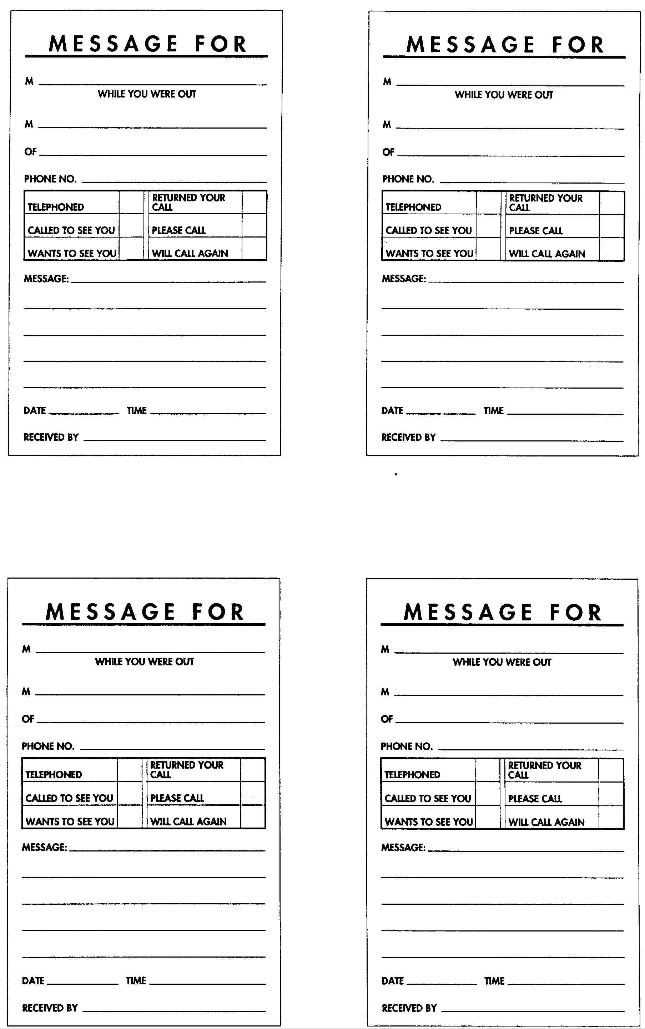
- Study the telephone message shown below and answer the following questions.

 | MESSAGE FOR
M | Karen Kassam
 | WHILE YOU WERE OUT
M | John Radcliffe
OF | MAKE Systems Inc.
PHONE NO. |  |  |  | 250-468-8954
 | TELEPHONED |  |  |  |  |  |  |  | RETURNED YOUR CALL
 | CALLED TO SEE YOU |  |  |  |  |  |  |  | PLEASE CALL
 | WANTS TO SEE YOU |  |  |  |  |  |  |  | WILL CALL AGAIN |  | 
MESSAGE: |  |  | Wants to meet with you to discuss
 | upcoming sales convention.
DATE |  | 01 17 |  |  |  | TIME |  |  |  | 14:43
RECEIVED BY |  |  |  |  | DCM

a) Who was the message for?

b) Who was the message from?

c) i) At what time was the message taken?

ii) Why is it necessary to indicate the time of the call?

d) i) What is the date (in conversational terms) of the message?

ii) Why should the message-taker note the date of the call?

e) What does the caller want?

f) Did the caller telephone or drop in personally?

g) Will the caller call back?

h) Should your employer write or call back?

i) What is the purpose of the operator's (message-taker's) initials?

7. You work for Bedford Educational Services Ltd. You have been asked to prepare a multimedia presentation on handling telephone calls for use in your company's orientation and training courses. The presentation should include information on handling incoming and outgoing calls, how to use voice and language effectively, and how to handle large numbers of callers.
- 8. What will an increase of 10 percent for telephone charges in April do to your overall costs? Produce a spreadsheet as follows, and then calculate the new costs resulting from the projected increase.
Telephone Costs | Jan. | Feb. | Mar.
Advertising | 1250 | 1300 | 1200
Production | 500 | 500 | 500
Purchasing | 750 | 800 | 850
Sales | 1000 | 1000 | 1000
Info. Processing | 1500 | 1550 | 1050
Administration | 500 | 600 | 1500
Marketing and Sales | 1000 | 1000 | 800
Totals

If you want to reduce telephone expenses, which department would you contact first? What suggestions might you make to reduce telephone costs?
9. While you and Mrs. Somerville were at lunch, one of your co-workers took the following messages for Mrs. Somerville. Analyze each of these messages and identify the problems that will arise when they are given to her:
- Unable to keep appointment tomorrow. Call to arrange a mutually satisfactory time (652-1068) for appointment to be rescheduled.
- Mr. Traubert (or Trabeth?) called. Please return his call at 855-3371.
- Mr. Nguyen called. He would like to meet with you this afternoon. Please call him back.
10. Debate the issue "It's a violation of a person's rights to restrict cell phone usage."

What Would You Do?
In the space provided, indicate what you would do in the following situations.
- You have to leave your desk for a while and your telephone will be unattended.

- You do not know the number you need to make an overseas call.

- You have been connected with the wrong number on a long-distance call.

- You want to know the cost of a long-distance call you made.

- Your main switchboard is out of order and you have to make an urgent telephone call.

- The computer is down and you need to find the telephone numbers of your customers right away.

- A good client of your company invites you, during a telephone conversation, to go out to dinner. You do not know whether this person is married.

- A salesperson, to whom your employer refuses to speak, constantly pesters you with calls.

- The caller says he would like to talk to your supervisor. He refuses to say who he is or what he wants. You have been told you must always announce callers.

- The caller wants to speak to your supervisor. You know she is out playing tennis with a client and will not be back until 3 p.m. It is now 11 a.m.

- The caller says he is Mr. Sweeney of Fast Eddy's Food Franchise. He says your supervisor knows him and will want to talk to him. Your supervisor tells you he does not want to talk to Mr. Sweeney.

- The caller wants to talk to your supervisor about a possible job in the firm. Your supervisor has a policy of speaking to job applicants only after they have been approved by the Human Resources Department.

- The caller is irate over a bill he claims he has paid. He demands to talk to Mr. Singh, who is in charge of accounting. You know that, in fact, the person who can be more helpful than Mr. Singh is Philip Wong, head of Accounts Receivable.

