UNIT
6 | Financial Management

Review Questions
Answer the following questions in the space provided.
- Why is it necessary to limit the amount of the petty cash fund?

- Which other financial institutions offer services similar to those offered by chartered banks?

- Which financial statement provides a summary of revenue, expenses, and net income or net loss?

- Which financial statement provides a picture of the financial standing of a company at a specific time?

- When would you use a blank endorsement, a full endorsement, and a restrictive endorsement?

- What should you complete before you actually prepare a cheque?

- What is the purpose of a:
- withdrawal slip?

- trial balance?

- petty cash fund?

- Why might a company select a business interest account?

- What is the main advantage of using an ATM?

- What is the difference between
- salaries and wages?

- piecework and commission?

- What is the difference between an operating budget and a capital expense budget?

- What is a:
- current account?

- personal chequing account?

- chequing savings account?

- daily interest savings account?

- Describe a/an:
- dishonoured cheque

- cancelled cheque

- NSF cheque

- voucher cheque

- stale-dated cheque.

- What investment term is used to describe the share of profit distributed among stockholders?

- What is a letter of credit?

- What information must appear on a deposit slip?

- Give three examples of source documents that provide information for accounting purposes.

- What information is provided in a monthly statement of account issued by a business?

- What does an employee earnings record show?

- The information recorded in a journal is posted to a customer's record. What is the name given to this record?

- Outline the features of a banking-by-telephone service.

- List five examples of voluntary deductions employers may make on behalf of employees.

- Information taken from source documents is recorded in a journal. Name three of the journals used for this purpose.

- If you make a mistake on a cheque, how can you solve the problem?

- How would you check that the petty cash balanced?

- List three compulsory deductions that employers must make from employees' pay cheques.

- How does a petty cash voucher prove that a legitimate payment was made?

- How are net earnings calculated?

- What name is given to a group of related accounts?

- What might the current-ratio and inventory-turnover ratio tell you about a company?

- How are financial statements used in a business?

- For what purposes might you use a spreadsheet in accounting?

- How often should the petty cash fund be replenished?

- An account records all transactions related to revenue, expenses, assets, liabilities, and owner's equity and drawings. How are the columns in each account headed?

- What is a bank reconciliation statement? What might cause a discrepancy between the balance shown in your records and the balance shown in the financial institution's records?

- What name is given to a mutual fund that invests in a combination of stocks and bonds?

Calculations
Insert the answers to the following calculations in the spaces provided.
- If a company's assets total $500 000 and its liabilities are $175 500, what is the value of the owner's equity?
____________________
- The balance in your company's Cash account is $4956.31. If you deposit cheques for $33.80, $42.11, $87.90, and $3498.60 and write cheques for $100.51, $365.44, and $67.09, what is the new balance in your company's Cash account?
____________________
- This month's income statement shows revenues of $12 300.50 and expenses of $5433.22. What is the net profit or net loss?
____________________
- This month's income statement shows a gross profit of $20 000, revenue of $60 000, and expenses of $30 000. Express gross profit as a percentage of revenue.
____________________
- Refer to question 4, what is the value of the Cost of Goods Sold?
____________________
- A bank collecting funds on your company's behalf charges 1.5% interest as a collection fee. How much will the bank earn for collecting a payment of $5950?
____________________
- Which is the wiser choice for investing $5000: (1) to invest in an RRSP for three years at the current rate of 12%; or (2) to put $3000 in a GIC paying 10% interest, and the remaining $2000 into a second mortgage loan paying 15% for the first year, 12% the second, and 10% the third?

- Your employer has a term deposit of $5000. If the annual interest rate for this deposit is 6.5%, how much interest will it earn in one year?
____________________
- Borrowing cash against your credit cards (VISA, for example) costs you interest on a daily basis. If you took out a loan of $250 for 10 days at a daily interest rate of 0.17% how much would you have to repay on the eleventh day?
____________________
- Using the exchange rates given below, calculate the cost of buying the following foreign currencies:
55 pounds sterling (1 pound = $2.15) ____________________
3000 lira (900 lira = $1) ____________________
75 Deutsche marks (1 DM = $0.65) ____________________
200 Australian dollars (1 A$ = $1.10) ____________________
- A petty cash fund was established with $100. At present, the petty cash box contains 2 x $20 bills, 1 x $10 bill, 2 x $5 bills, and 1 loonie. How much cash is in the petty cash box?
____________________
- In question 11, how much money has been paid out of the petty cash?
____________________
- In question 11, what should be the total value of the petty cash vouchers?
____________________
- In question 11, if the petty cash were replenished now, what would be the amount of the petty cash cheque?
____________________
- On September 7, you record a $125 cheque to establish a petty cash fund. On September 30, you have the following vouchers in your petty cash: $49.90 for a delivery, $20.40 for a taxi fare, $24.10 for stationery, and $6.60 for postage stamps. How much money is left in the petty cash box?
____________________
- An employer must contribute 1.4 times the amount of EI deducted for each employee. If all of the employees of a company together paid EI premiums of $297.46, what is the amount of the premium paid by the company?
____________________
- In question 16, what would be the amount of the total remittance by the company to Canada Customs and Revenue Agency?
____________________
18. a) What does Warren Spetz earn for a day if he works for five hours at $5 per hour, plus two hours' overtime at time and a half?
____________________
b) If gross pay minus deductions equals net pay, what is Nico's net pay for this week? Gross pay $250, pension $7.20, EI $1.20, income tax $29.50, group life $6.70.
____________________
- If a salesperson on straight commission sells $10 000 worth of goods in a month, what will that person's earnings be for the month, based on a 17.5% commission rate?
____________________
- Would a salesperson make more money earning a weekly salary of $425, or a weekly rate of $200 plus 5% commission on $5000 of sales?
____________________

Research Activities
- Provide short definitions for the following financial terms. Present your final list in alphabetical order: drawings account, write-off, depreciation, liquidity, debenture, audit, shareholder's equity, retained earnings, fiscal period, capital, ratios, marketable securities, amortization, mortgage, proxy, capital cost allowance, stock option.
- There are a number of ways for people to become qualified as accountants. The three top qualifications are: CA, CGA, and CMA.
Find out what is involved in becoming each of these, where they lead, and what the essential differences are.
- Most companies produce an annual report that shows their financial results for the previous year. Contact a company whose product or service interests you and request a copy of the annual report. Present to your class a short talk on items of interest that you found in the report.
- Contact four local businesses of various sizes. Find out if all, some, or none of the accounting is computerized. Do they do all of the accounting themselves, or is some done by an outside company? Ask specifically about receivables, payables, inventory, payroll, and financial reporting. What software do they use? Are they willing to share with you their thoughts on the advantages and disadvantages of their software packages? (Create a list of questions and a sheet for recording responses before you start.) Blend the information you obtain into a short report.
- As customers of financial institutions become accustomed to using computers for their banking needs, more services are becoming available via automated banking machines (ATMs). Find out what plans three financial institutions have for increasing their ATM, bank-by-phone, and on-line banking services.
- Contact a bank, a trust company, and a credit union and find out their rates or charges for the following:
- chequing savings account
- non-chequing savings account interest rate
- term deposit interest rate for $5000 for one year
- rate of interest for a daily interest savings account
- cost of personal loans to customers with good credit ratings
- cost per cheque
- cost of NSF cheques
- cost of certifying cheques
- mortgage rates
Present the information as a comparative chart. Form some conclusions, based on your findings, and include these also on your chart.
- What is a debit card? How does it differ from a credit card? Does it have advantages for the consumer or only for the retailer? Discuss this with a financial institution employee and find out the latest information. Present your findings in an oral or written report.
- Make a presentation on interbranch banking after doing some thorough research on what services are offered under this name.
- Financial institutions will, under certain circumstances, stop payment on cheques. Ask one of these institutions for examples of the types of circumstances that are acceptable and those that are not. Obtain copies of related forms that must be completed. Finally, turn this information into a short report entitled "Stopping Payment on a Cheque."
- When a cheque is given to someone, that person deposits the cheque in his/her account, the money is deducted from the maker's account, and the cancelled cheque is eventually returned to the maker with his/her statement. This process is known as clearing a cheque. Find out exactly what happens in the clearing process and write a brief report on your findings.
- Have you ever considered a career in banking? Find out what opportunities exist and what qualifications you require.
- Under the North American Free Trade Agreement, is there an open market for banking throughout the three countries? What effect could this have on small businesses? Large businesses?
- Research the current use of Mondex and/or similar smart cards in North America and other parts of the world. Is the use of cell phones for purchasing small cash items such as soft drinks from vending machines negating the use of smart cards? Present your findings in an oral report.
- On January 1, 1987, the federal government started to change the Canada Pension Plan. Changes will occur each year until 2011.
- How do the changes affect the average person?
- How do the changes affect an employer?
- List ways in which you can keep abreast of the changes that might affect you from a personal and an employment point of view.
- Prepare a chart listing the employee and employer's percentage contributions to CPP from the current year to 2011.
- Obtain CPP information booklets and prepare a report on the Canada Pension Plan. Include a full description of the benefits available.
- Contact companies in your area to see how they handle their payroll. Do they use manual or computerized systems? If they use computerized systems, which software packages are they using? Find out what problems, if any, they experience when doing their payrolls. Discuss your findings with your colleagues.
- Sometimes companies "pay" temporary helpers with non-cash items (e.g., shares in the company or equipment, such as computers). In some circumstances, companies will use the barter system (e.g., you help me set up my computer system and I'll do the electrical wiring in your office free of charge). How prevalent, and how legal, is this non-cash form of payment? Discuss your findings with your colleagues.
- Contact companies in your area to see how they handle their petty cash. Do they use manual or computerized systems? If they use computerized systems, which software packages are they using? What procedures have the companies implemented for the handling of petty cash? Who is responsible for the petty cash? Present your findings in a short, written report.

On-the-Job Activities
- Ed Petrov is the owner of Ed's Trailers, a small business that renovates used recreational vehicles. On pages 74-79 are Ed's Trailers' Cash Payments Journal, Cash Receipts Journal, Accounts Payable Ledger, Accounts Receivable Ledger, General Ledger, income statement, and balance sheet. Examine these and then answer the following questions in the space provided.
a) How much money is Ed's Trailers owed by its customers?
____________________
b) Two of its assets could be described as current assets. Which are these?

c) What is the total amount owed by the firm to all of its creditors?
____________________
d) How much does the firm owe to its owner as at August 31?
____________________
e) Current liabilities are described as those that should be paid in one year. What is the total of current liabilities for Ed's Trailers?
____________________
f) What was the amount of gross revenue for the month of August?
____________________
g) How was the net income figure calculated?

h) On which part of the balance sheet does the net income amount have an effect?

i) The liquidity of a firm is its ability to pay its debts. One method of testing this is by calculating the acid-test ratio. What is the acid test ratio for Ed's Trailers?
____________________
j) If a firm is in a strong position, the claim of the creditors on the business should not be greater than 50 percent. The calculation is done by dividing total liabilities by total assets and multiplying by 100. What is the creditors' percentage claim on Ed's Trailers?
____________________
k) How many invoices were issued by Ed's Trailers in August? What were the invoice numbers?

l) How many cheques were received and deposited by Ed's Trailers in August?
____________________
m) How many bills did Ed's Trailers pay by cheque in August? What were the cheque numbers?

n) What is the number of the Mortgage Payable account?
____________________
o) If Ed Petrov had bought $500 of equipment for cash, would the balance sheet totals be the same as shown for August 31? Explain your answer.

p) What was the value of the E. Petrov, Capital account at August 17?
____________________
- Ed Petrov asks you to prepare a trial balance for Ed's Trailers as at August 31, to check the accuracy of the General Ledger.
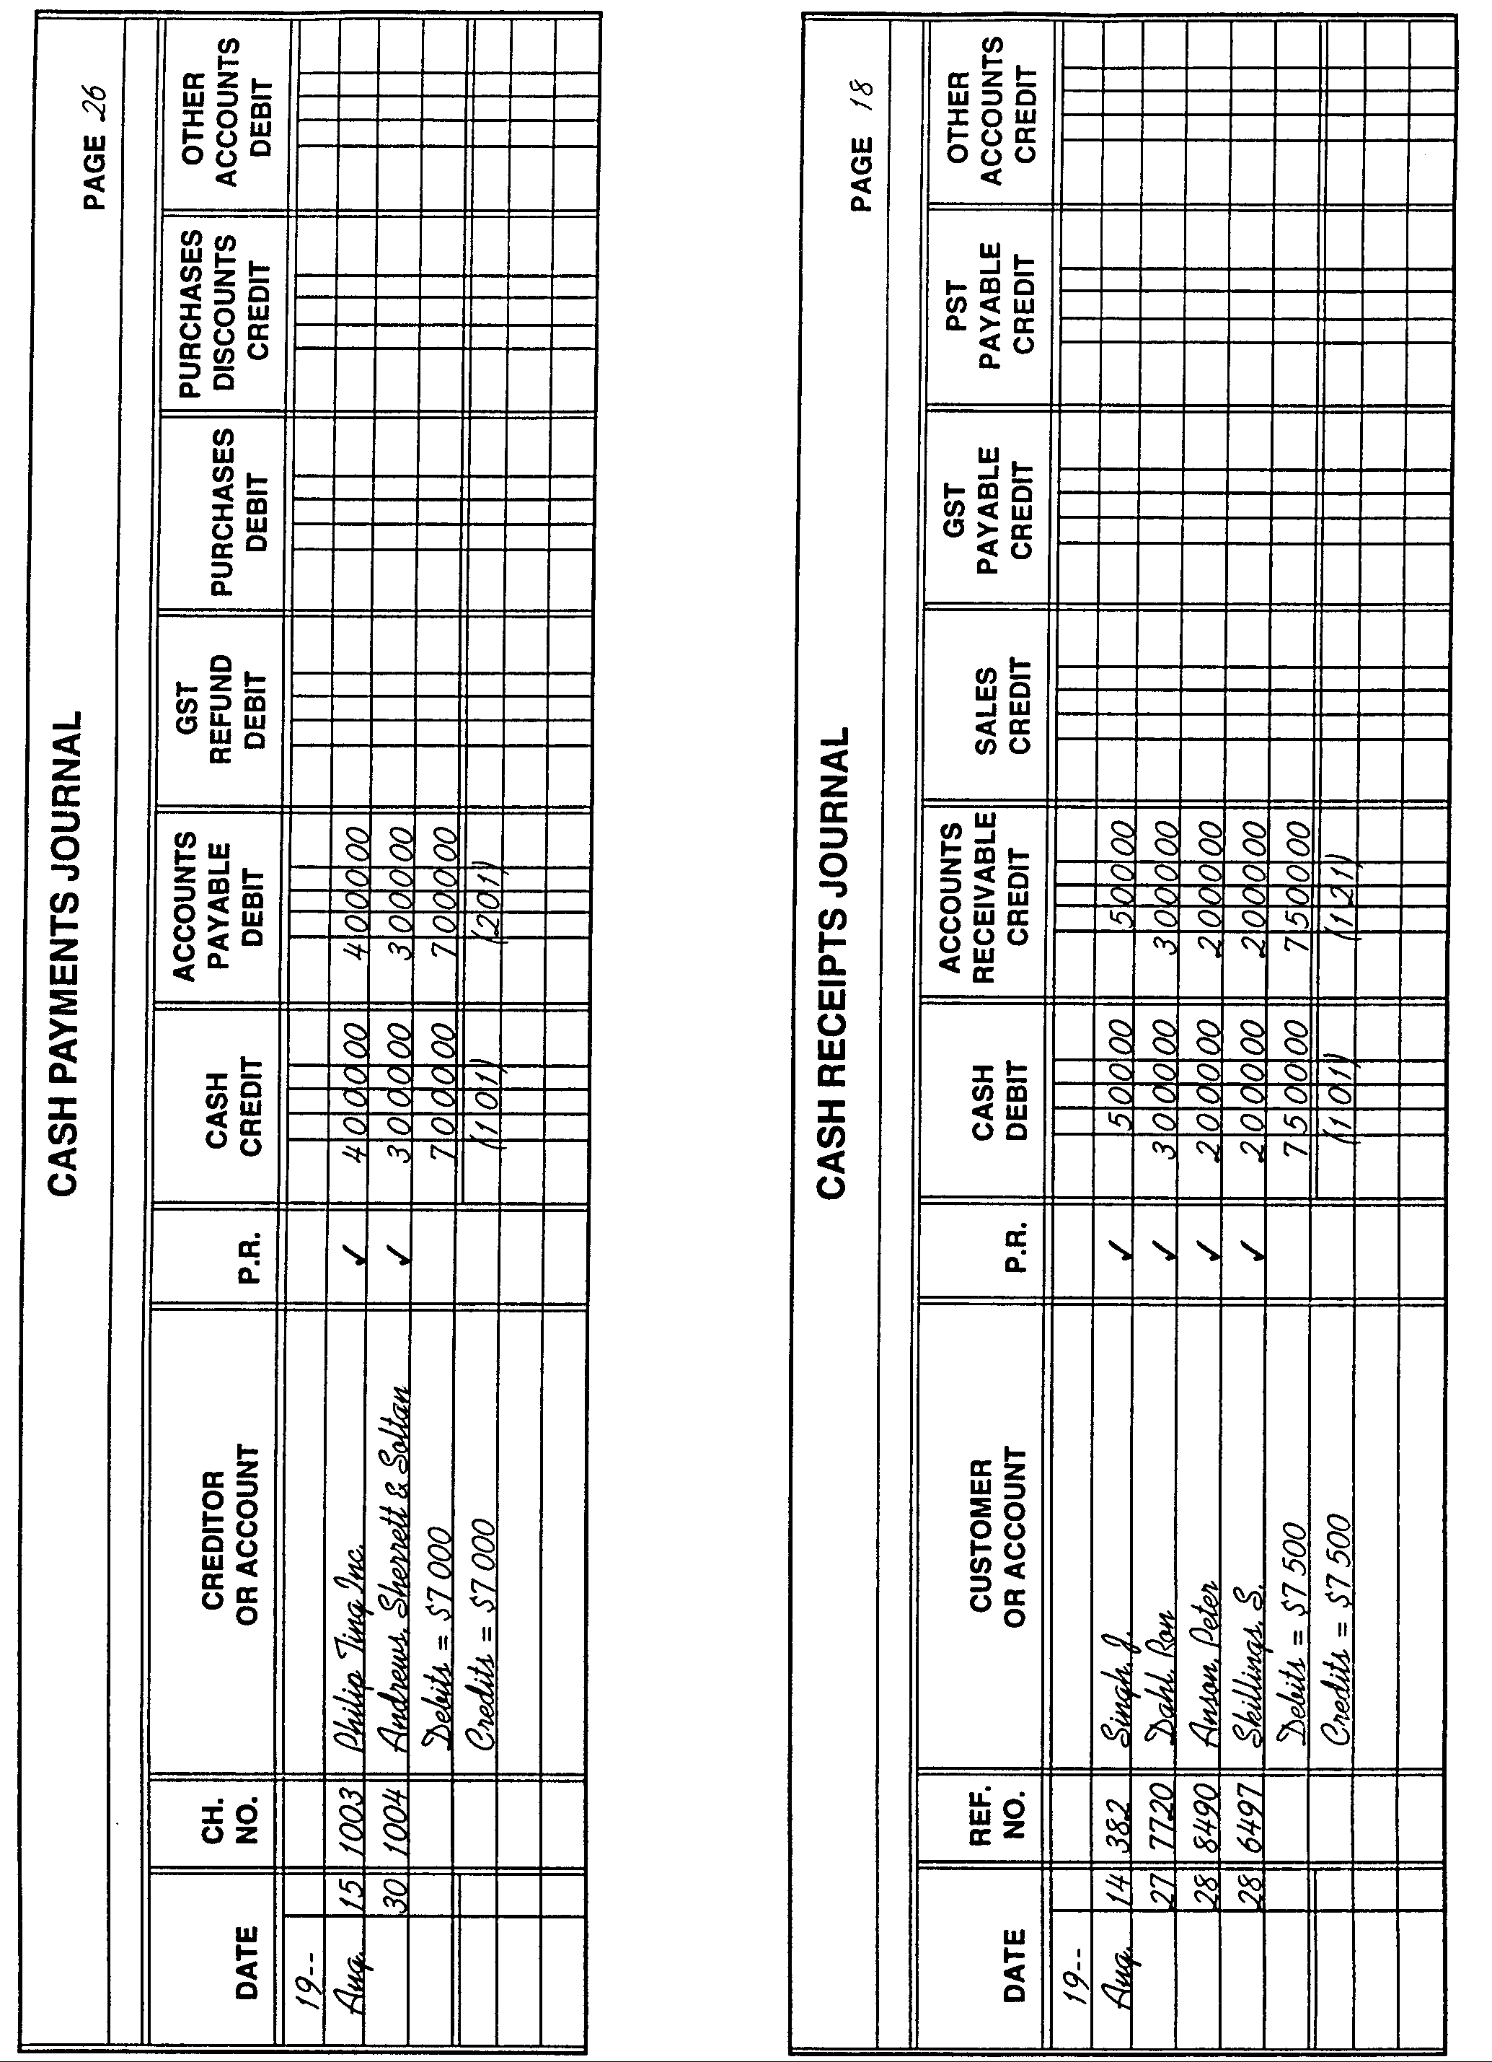
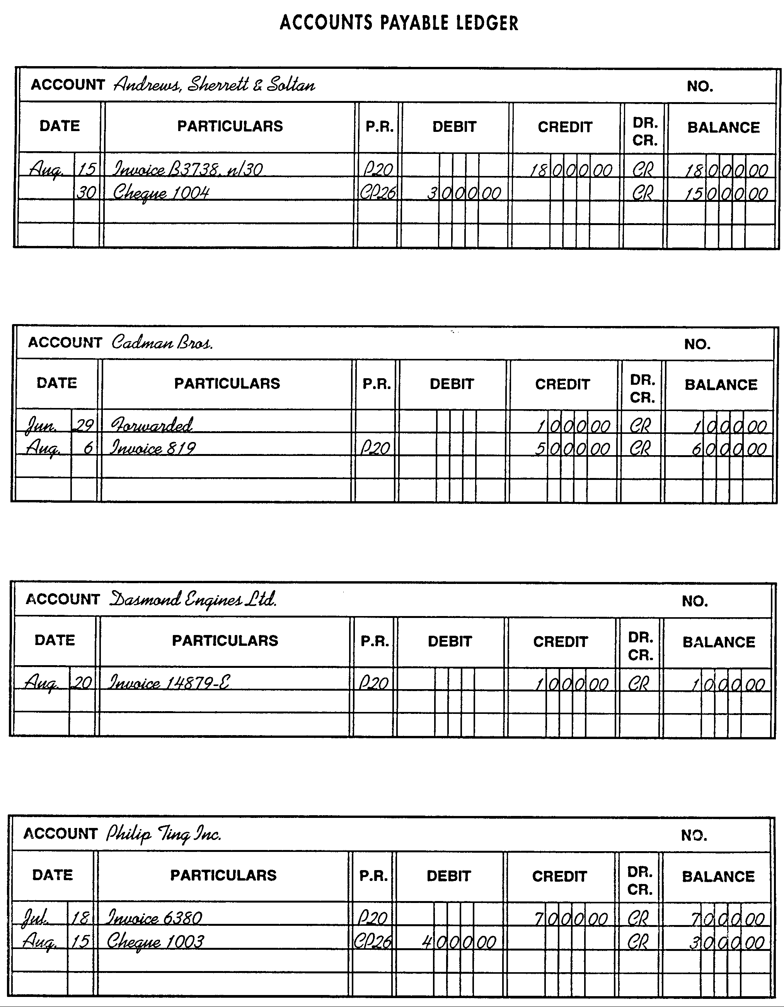
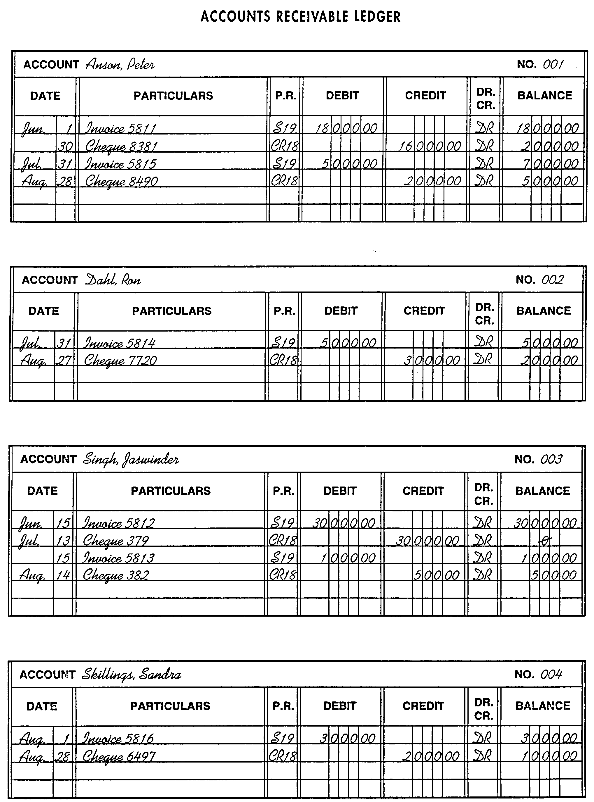
E. Petrov, Capital
E. Petrov, Drawings
Ed's Trailers
Income Statement
For the Month Ended August 31, [Year]
 | Revenue
 | Sales |  |  | $87 800
 | Expenses
 | Salaries Expense |  | $57 000
 | Maintenance Expense |  | 9 000
 | Utilities Expense |  | 3 200
 | Telephone Expense |  | 1 100
 | Advertising Expense |  | 7 500
 | Net Income |  |  | 77 800
 |  |  |  | $10 000

Ed's Trailers
Balance Sheet
as at August 31, [Year]
 | Assets |  |  |  | Liabilities
 | Cash | $ 1 500 |  |  | Accounts Payable | $ 34 000
 | Accounts Receivable | 8 500 |  |  | Bank Loan | 5 000
 | Land | 35 000 |  |  | Mortgage Payable (25 yrs.) | 32 000
 | Building | 35 000 |  |  | Total Liabilities | 71 000
 | Machinery and Equipment | 10 000
 | Trucks | 10 000
 |  |  |  |  | Owner's Equity
 |  |  |  |  | E. Petrov, Capital | 29 000
 |  |  |  |  | Total Liabilities and
 | Total Assets | $100 000 |  |  | Owner's Equity | $100 000

- Ed Petrov asks you to prepare a Schedule of Accounts Receivable and a Schedule of Accounts Payable as at August 31.
- Create an income statement and a balance sheet from the following data, using the last day of the previous month as the income statement date.
Note: Service businesses do not need a Cost of Goods Sold section. Gross income less expenses equals net income.
- Your spreadsheet shows the following information for your company's income statement for last month, July.

 | Revenue
 | Sales |  | $550 000
 | Expenses
 | Advertising Expense | $18 000
 | Rent Expense | 70 000
 | Salaries Expense | 270 000
 | Transportation Expense | 12 000
 | Total Expenses |  | 370 000
 | Net Income |  | $180 000
You are to update the figures and print the comparative income statements for July and August. Your revenue increased by 17%. Your expenses also increased because you spent $4000 more on advertising and $13 500 on transportation expenses.
- Budgeting is an important management tool that provides a means of financial control over an organization's activities:
- Budgets are based on past performance and on short- and long-term goals.
- Financial and other resources can be allocated in advance.
From regularly prepared operating reports, managers can see where adjustments and decisions must be made.
a) The expenses budget allocation for your organization has been made as follows: sales, 20%; advertising, 14%; accounting, 15%; production, 14%; human resources, 5%; legal, 4%; administration, 9%; transportation, 6%; library, 5%; purchasing, 8%. Create an attractive pie chart to show the percentage allocations.
b) Using your spreadsheet software, enter the budget figures shown below. Calculate the discrepancy figures and column totals. Print your report.

 | Budget | Actual | Discrepancy
Accounting (15%) | $ 37 500 | $ 38 400
Administration (9%) | 22 500 | 23 500
Advertising (14%) | 35 000 | 39 500
Human Resources (5%) | 12 500 | 13 000
Legal (4%) | 10 000 | 8 000
Library (5%) | 12 500 | 12 500
Production (14%) | 35 000 | 32 100
Purchasing (8%) | 20 000 | 19 000
Sales (20%) | 50 000 | 47 000
Transportation (6%) | 15 000 | 15 000
Total
c) Now do the following in the space provided:
(i) Identify problem areas.

(ii) Make recommendations on how next year's budget might be amended, assuming that your total expenses budget remains unchanged.

- Your company sells gift items to stores. It is doing very well but is having a cash flow problem. You are required to send a letter each month to quite a few customers who do not pay their accounts on receipt of their monthly statements. Look at the example of a form letter provided in Unit 1, C147, of the Pitman Office Handbook (or other reference source) and key a form letter that will suit your purpose. Note: It is a well-known fact that a touch of humour or something eye-catching, fresh, and original works better in debt collection than a menacing tone.
The variables you should allow for are date, name and address, salutation (after "Dear"), date of statement, amount owing, date by which you expect to receive payment, and name of area salesperson to contact in case of difficulty.
- The July 31 and November 30 balance sheets for Malibu Gym are shown below. Compare the two balance sheets and answer the questions that follow. Give reasons for all of your answers in the space provided.

 | Malibu Gym  Balance Sheet  July 31, [Year] |  |  |  |  |  | Malibu Gym  Balance Sheet  November 30, [Year]
 | ASSETS |  |  |  |  |  |  | ASSETS
 | Current Assets |  |  |  |  |  |  | Current Assets
 | Cash | $ 5 000 |  |  |  |  |  | Cash |  | $ 7 800
 | Accounts Receivable | 6 000 |  |  |  |  |  | Accounts Receivable |  | 2 600
 | Office Supplies | 500 |  |  |  |  |  | Office Supplies |  | 695
 | Total Current Assets |  |  | $ 11 500 |  |  |  | Total Current Assets |  |  | $ 11 095
 | Fixed Assets |  |  |  |  |  |  | Fixed Assets
 | Land | 25 000 |  |  |  |  |  | Land |  | 25 000
 | Building | 110 000 |  |  |  |  |  | Building |  | 110 000
 | Training Equipment | 94 500 |  |  |  |  |  | Training Equipment |  | 99 235
 | Total Fixed Assets |  |  | 229 500 |  |  |  | Total Fixed Assets |  |  | 234 235
 | Total Assets |  |  | $241 000 |  |  |  | Total Assets |  |  | $245 330
 | LIABILITIES AND OWNER'S EQUITY |  |  |  |  |  |  | LIABILITIES AND OWNER'S EQUITY
 | Current Liabilities |  |  |  |  |  |  | Current Liabilities
 | Accounts Payable |  |  | $ 4 000 |  |  |  | Accounts Payable |  |  | $ 10 900
 | Long-Term Liabilities |  |  |  |  |  |  | Long-Term Liabilities
 | Bank Loan | $ 65 000 |  |  |  |  |  | Bank Loan |  | $ 63 000
 | Mortgage Payable | 80 000 |  |  |  |  |  | Mortgage Payable |  | 79 800
 | Total Long-Term Liabilities |  |  | 145 000 |  |  |  | Total Long-Term Liabilities |  |  | 142 800
 | Total Liabilities |  |  | 149 000 |  |  |  | Total Liabilities |  |  | 153 700
 | Owner's Equity |  |  |  |  |  |  | Owner's Equity
 | S. O'Brien, Capital July 1 |  |  | 92 000 |  |  |  | S. O'Brien, Capital July 1 |  | 90 680
 | Total Liabilities and Owner's Equity |  |  | $241 000 |  |  |  | Add: Net Income for November | $2 450
 |  |  |  |  |  |  |  | Less: S. O'Brien, Drawings | 1 500
 |  |  |  |  |  |  |  | Increase in Capital |  | 950
 |  |  |  |  |  |  |  | S. O'Brien, Capital November 30 |  |  | 91 630
 |  |  |  |  |  |  |  | Total Liabilities and Owner's Equity |  |  | $245 330
- Has the financial position of the business improved, weakened, or stayed approximately the same during the first five months of operation?

- What additional information would you want to see to determine whether O'Brien has been successful in this venture to date?

c) Does the current balance sheet indicate any potential problems for O'Brien? Explain your answer.

- Why has the value of the mortgage stayed approximately the same even though O'Brien has made regular monthly payments?

- O'Brien's capital has decreased. Does this mean the business has a total net loss for the five months of operation? Explain your answer.

- Use the information provided in Unit 6, FM19, of the Pitman Office Handbook to help you complete this chart.
 | Current | Personal Chequing | Chequing Savings | Daily Interest Savings | Investment
Most Suited for Use by
Interest Payable? Y/N
Cheque Writing Possible? Y/N
Methods of Making Withdrawals
Cancelled Cheques Returned? Y/N

- Prepare the cheques and deposits for Ed's Trailers for August (see On-the-Job Activity 2) using the following forms. Ed Petrov insists that deposits are made every day. The Cash account balance at the start of business on August 15 is $1500. Ed's Trailer's bank account number is 101977-7.

- Below is a reprint of a bank account statement. Examine this statement and then show your skill in reading such statements by answering the questions that follow in the space provided.

 | FRIENDLY TRUST COMPANY |  |  | Branch |  | 5422
 | CURRENT ACCOUNT STATEMENT |  |  | Account No. |  | 04-17435
 |  |  |  | Statement Date |  | July 8, [Year]
 | P. Sullivan Enterprises |  |  | Enclosures |  | 9
 | 2111 Dunkirk St. N. |  |  | Page |  | 1
 | Lethbridge, AB T1J 4E5
 | DATE | DESCRIPTION |  | DEBITS | CREDITS |  | BALANCE
 | 06/05 | Balance forward |  |  |  |  | 2419.85
 | 06/08 | Cheque 389 |  | 305.82
 |  | Cheque 392 |  | 520.00 |  |  | 1594.03
 | 06/10 | Cheque 393 |  | 143.93 |  |  | 1450.10
 | 06/11 | Cheque 395 |  | 389.80 |  |  | 1060.30
 | 06/15 | Cheque 397 |  | 280.51 |  |  | 779.79
 | 06/19 | Deposit |  |  | 100.00 |  | 879.79
 | 06/23 | Cheque 391 |  | 89.88
 |  | Deposit |  |  | 100.00 |  | 889.91
 | 06/26 | Deposit |  |  | 3962.43 |  | 4852.34
 | 06/30 | Cheque 398 |  | 619.08
 |  | Cheque 396 |  | 361.10
 |  | Cheque 390 |  | 2460.00 |  |  | 1412.16
 | 07/03 | Cheque 394 |  | 389.90 |  |  | 1022.36
 | 07/08 | Service charges |  | 21.80 |  |  | 1000.56
 |  |  |  | 5561.72 | 4162.43 |  | 1000.56

- What type of account does this depositor hold?

b) What is the depositor's account number?

c) What is the account holder's name?

d) At which branch of the trust company does the account holder hold its account?

e) What was the opening balance on the account?
____________________
f) Do debits have the effect of reducing or increasing the balance on the account?

g) What is the closing balance on the statement?
____________________
h) By how much did debits exceed credits for the period of the statement?
____________________
i) How much did the trust company charge for the work it did on behalf of the account holder?
____________________
j) How much interest did the account holder earn over the period of this statement?

- Below is a typical account (bank) reconciliation statement. Show your skill in understanding such statements by correctly answering the questions that follow in the space provided.

Schoettlin Office Products
Account Reconciliation Statement
March 31, [Year]
 | Balance as per account statement, March 31, [Year] |  |  |  | $2761.16
 | Add: Deposit of March 31 not recorded by bank |  |  |  | 295.14
 |  |  |  |  | 3056.30
 | Deduct: Outstanding Cheques: No. 37 |  | $ 95.55
 | No. 48 |  | 195.80 |  | 291.35
 | Adjusted bank balance |  |  |  | $2764.95
 | Balance as per Cash account, March 31, [Year] |  |  |  | $2843.70
 | Add: Interest on term deposit |  |  |  | 37.50
 |  |  |  |  | 2881.20
 | Deduct: Charge for safety deposit box |  | $ 7.50
 | NSF cheque: J. Kelly |  | 86.75
 | Loan interest cost |  | 10.00
 | Monthly service charge |  | 12.00 |  | 116.25
 | Adjusted Cash account balance |  |  |  | $2764.95

a) What effect did the two outstanding cheques have on the balance as per the account statement?

b) How many "discrepancy" items must be included when adjusting Schoettlin's record to make it agree with the account statement?

c) Why had Schoettlin not already included these "discrepancy" items in its records?

d) What effect did interest earned have on Schoettlin's record of its account balance?

e) Was Schoettlin in error to show the account balance as $2843.70 when in fact it should have been $2764.95? Why or why not?

f) Why is it necessary to deduct the NSF cheque of J. Kelly for $86.75 from the amount shown in Schoettlin's Cash account?

g) Will Schoettlin inform the financial institution that its statement should, in fact, show a balance of $2764.95? Why or why not?

- Your employer (J. Chow & Associates) has asked you to reconcile his account statement with his own records for the month of July. The account statement shows a balance of $1019.96; your employer's Cash account record shows a balance of $897.42. Three cheques are outstanding according to the account statement: No. 41 for $127.50; No. 42 for $100; and No. 43 for $389.80. A deposit you recently made of $494.16 does not appear on the statement either. Your records do not carry a 60-cent service charge shown on the statement. Prepare an easy-to-understand reconciliation statement for your employer to explain the differences in the account statement and his Cash account record.
- Shown below is one example of the type of earnings statement employees can expect to receive with their earnings. Show your understanding of the information it contains by completing the questions that follow in the space provided.
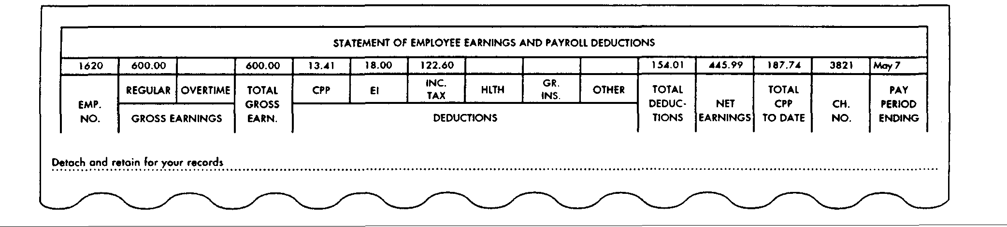
a) What were the total earnings?
____________________
b) How much was taken off in total?
____________________
c) What was the take-home pay?
____________________
d) What does CPP mean?

e) What is EI?

f) Why is Gr. Ins. left blank?

g) How much overtime was worked?
____________________
h) What happens to the three deducted amounts?

i) What is the payroll cheque number?
____________________
j) What do the terms gross and net mean?

k) What is the employee number?
____________________
1) What is the total of the CPP contributions made this year?
____________________
- The following is a section of your company's Payroll Journal. Using a spreadsheet, complete and print the payroll using the following information:
- Taxable earnings are gross earnings minus the sum of RPP and union dues.
- Total deductions are the sum of the Non-Taxables and Other Deductions columns.
- Net earnings are gross earnings minus total deductions.
- Nancy Sakamoto is paid $6.50 per hour. She is paid time and one-half for any hours over eight worked in one day. Calculate her gross earnings if she works the following hours:

Monday, 8; Tuesday, 7.5; Wednesday, 10; Thursday, 7.75; Friday, 8; and Saturday, 4.
____________________
- Jody Piers is paid a basic salary of $220 per week plus 2.5% commission on sales. The sales made for four weeks are: Week 1, $11 680; Week 2, $13 493;
Week 3, $18 514; and Week 4, $9 400.
a) Calculate the gross earnings for each week and the total earnings for the month.
Week 1: ____________________
Week 2: ____________________
Week 3: ____________________
Week 4: ____________________
Total: ____________________
b) If Jody had received a straight commission of 5% of sales, what would have been her month's commission?
____________________
- Dan Riechers works for a firm producing refrigerator components. He is paid according to the number of components he assembles. Calculate Dan's gross earnings for each day of the week if he is paid $1.59 for each assembly. Monday, 70; Tuesday, 74; Wednesday, 81; Thursday, 87; and Friday, 75.
Monday: ____________________ Thursday: ____________________
Tuesday: ____________________ Friday: ____________________
Wednesday: ____________________
- Determine the gross earnings for each of the following employees: C. Giaradelli: 40 hours @ $12.60; M. Murphy: 39 hours @ $9.00; V. Katz: 40 hours @ $14.50; and S. Tattman: 38 hours @ $13.85.
If each employee works five hours of overtime in addition to the regular hours, and is paid time and one-half for each hour of overtime, what are the gross earnings for each?
Gross Earnings Plus Overtime Earnings
C. Giaradelli: ____________________ ____________________
M. Murphy: ____________________ ____________________
V. Katz: ____________________ ____________________
S. Tattman: ____________________ ____________________
- Sally Basaraba contributes $14 per week to the company pension plan and $10 per week to union dues. Calculate her taxable earnings for each week in July if her gross earnings for the four weeks were: Week 1: $498.75; Week 2: $525.64; Week 3: $519.26; and Week 4: $507.49.
Week 1: ____________________
Week 2: ____________________
Week 3: ____________________
Week 4: ____________________
- The business you work for is just starting out. From time to time, you have bought supplies or paid for postage and have not bothered to claim for it. Because no petty cash system exists, a cheque would have been needed to reimburse you. Write your employer a memo suggesting the time has come, in your opinion, to implement a fund. Describe how the fund will be operated, to what kinds of uses it should be put, how much money you feel it should contain, and who should be responsible for it.
- You are responsible for your company's petty cash fund. Your office has computers and spreadsheet software. You are wondering if it would be possible to save yourself some time and energy by computerizing your records.
Discuss this in groups; then, individually, create a brief report on how a spreadsheet might be used. Now divide the rest of your report into two columns headed Advantages and Disadvantages and record your thoughts. What is your final decision on the possibility?
- Review in the Pitman Office Handbook or another reference source the procedure for keeping a petty cash fund and then complete the following assignment. (Use the forms provided here.) Your petty cash fund was replenished on April 1 with $100. The last voucher issued was No. 19. On April 4, you spent $12.50 on stamps; on April 8, you paid $10.25 for a taxi fare to deliver an urgent package; on April 17, you reimbursed an employee for $2.71 spent on a special marking pen; on April 24, you paid out $25 as a donation to the Cancer Society; and on April 24, you paid $6 for cups for the coffee machine. On April 30, you do two things:
a) Total the columns and calculate the cash on hand.
____________________
b) Issue a petty cash requisition to replenish the fund.
Total disbursements: ____________________
Cash on hand: ____________________
Amount of petty cash fund: ____________________

PETTY CASH BOOK
For the Month of April 20--
Date | Explanation | Voucher No. | Receipts | Payments
Apr. 1 | Opening Balance |  | $100.00

PETTY CASH REQUISITION
Request to Replenish Petty Cash
for Period April 1 to April 30, 20--
Petty cash summary:
Total disbursements
Cash on hand
Amount of petty cash fund
- Today is June 29, 20--. Kyle Switzer has bought some postage stamps for $4.72 (including GST) and a box of photocopying paper for $24.95 (including GST). He asks you for a reimbursement from petty cash. You check the petty cash fund and see that the following was the last voucher issued. You check the General Ledger and find that there are accounts for Supplies, Postage Expense, and GST Paid. Prepare the appropriate voucher(s).

PETTY CASH VOUCHER
 | No. |  |  | 36
 | Date: |  |  | Jun. 29, 20--
 | Amount: |  |  |  | $14.95
 | For: |  | Coffee for employee lounge
 | Account to be charged: |  |  |  |  | Misc. Expense
 | Approved by: |  |  |  |  |  |  | B. Mallet
 | Received by: |  |  |  |  |  |  | A. Hodgson
 |  |  |  |  |  |  | (Signature)

PETTY CASH VOUCHER
No.
Date:
Amount:
For:
Account to be charged:
Approved by:
Received by:
(Signature)

PETTY CASH VOUCHER
No.
Date:
Amount:
For:
Account to be charged:
Approved by:
Received by:
(Signature)

What Would You Do?
In the space provided, indicate what you would do in the following situations.
- A cheque that you received in payment of an outstanding debt is returned to you by the bank marked NSF.

- An employee asks you to amend her net claim code to reduce the amount of income tax she pays each payday.

- One of the employees comes to you on a Wednesday and asks you to give her an advance against her Friday pay cheque. She needs the money to pay for a new pair of glasses. She broke hers when she tripped over a cable in the office.

- One of your co-workers asks you to give her some money from the petty cash for her bus fare home because she had her purse stolen at lunch time.

- Payment is required for the rental car your travel agent booked for you in Tokyo; however, the money is required in Tokyo, not in Canada.

- Sylvia Tsang asks for reimbursement from petty cash for a taxi fare to visit a client. She forgot to get a receipt.

- The head of the accounting department tells you that Mary Saunders' wages are being garnished. You are to send $1000 of Mary's monthly pay cheque to the Court. Mary comes to you and tells you that you need not do this because she will pay the Court when she gets her pay cheque.

- The payroll in your organization has been looked after very efficiently for a long time by an older individual who is speedy, has an excellent memory and arithmetic skills, and has never made an error. The new chief accountant insists that the payroll be computerized immediately. The older individual asks for your support in a protest against using the computer.

- The petty cash fund does not balance by $4. One of your co-workers tells you not to worry – just put in $4 of your own money and if the fund is over some time, you can take the money out. "In the end," your co-worker says, "it'll all even out."

- There are two receptionists at your organization: yourself and Hugh Radomski. You both have access to the $200 petty cash fund. You notice several vouchers (with receipts attached). On close examination, you notice that the receipts could be from any store because they do not provide the purchase description. You know that Hugh is short of money at the moment and you think that he may be "borrowing" from petty cash.

- You forget to replenish the petty cash. A courier asks for $15 for a delivery and you have only $5 in the petty cash box.

- You receive a cheque from a client but there is a spelling mistake in the name of your company.

- You receive a batch of time sheets from the employees. You notice that one of the employees is claiming overtime of two hours for Wednesday of this week. You saw this employee leaving the office at 5:30 p.m. that day, so you know that no overtime was worked.

- You operate your own business. You have just completed some work for a client. The client gives you a cheque for $10 000. It is Sunday evening and you are leaving on a business trip first thing in the morning. You do not want to lose interest on this money.

- You have been hired to work as a temporary accounting clerk for Mel's Delivery Service. The accountant, Jan Melores, is away on a medical leave. You discover that Jan does not use a journal but simply records all transactions in the ledger. You realize that Jan knows the business well but you do not and you are concerned about making or being able to find errors.

- You have been asked to prepare a trial balance. You do this but the debit column does not equal the credit column.

- You have been asked to assist in the accounting department but you do not have any formal accounting training. You are given a purchase invoice that shows that your company bought some equipment for $15 000. Shipping and handling, GST, and PST have been added to this figure. You are sure that the Equipment and Accounts Payable accounts are involved but you are not sure what to do with the shipping and handling charges and the taxes.

- You cannot make your bank account reconciliation balance. You are sure the financial institution has made an error.

- You are working for a small firm. Its owner says that she will not deduct employment insurance from your earnings, thus saving you about $1000 a year and her about $1400.

- You are a junior accounting clerk. At the end of the first month of working at XYZ Corporation, you prepare the schedules of accounts payable and receivable, a trial balance, an income statement, and a balance sheet. Everything balances. You are very pleased with yourself. When you go into the office the next day, you notice that someone has changed some of the figures in the accounts with correction fluid. The books still balance, but you are concerned.

- You accidentally make an entry in the Cash Payments Journal instead of the Cash Receipts Journal.

- On the way to make the daily deposit of cash and cheques for your company, you are accosted by a stranger who demands the money.

