INSTRUCTIONS FOR IMPACT TESTING
OF CHARPY SAMPLES

Note: One operator, designated as Operator 1 in Step 4, is involved in all six steps of the
following process. The other, designated as Operator 2, helps in step 4 only.

Equipment And Materials

The test requires the following equipment and materials:
- a SATEC impact tester, model no. S1-1C
- 2 Charpy specimens AISI 1018 CR
- 2 Charpy specimens AISI 1020 HR (annealed)
- 1 pair of specimen holding tongs
- 1 wooden safety block, approximately 2” X 4” X 8”

The Process

Prepare the impact tester for the test brake handle release lever

(see Figure1 for relevant parts) red safety pin
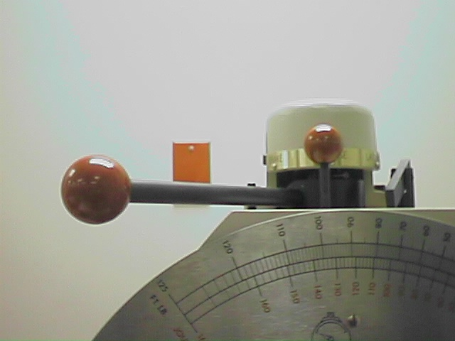
  - Remove the red pin which is lodged vertically
on the top of the SATEC impact tester.

  - Hold down the release lever with your right-hand
index finger and then, with your left hand, push
the horizontal handle all the way to the right,
to the latched position.

  - Release the lever so it falls over top of the handle.

1.4 Place the safety pin back in its position.

Figure 1. Brake components

- Prepare the tester for the specimen mount safety block hammer
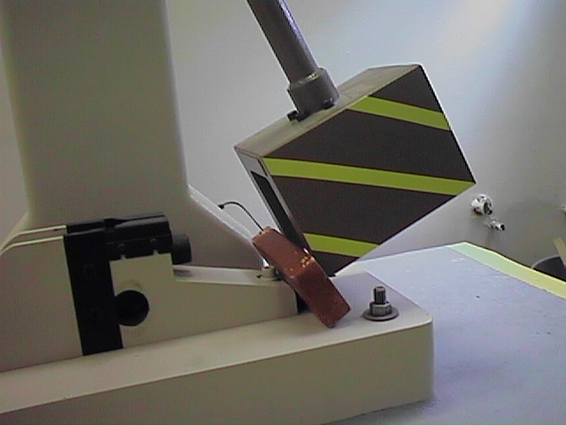(see Figure 2 for proper final positioning)

2.1 With your right hand, grab the hammer shaft
and raise the hammer counter-clockwise about
30 degrees.

2.2 Using your left hand, place the safety block
against the bottom part of the mount and release
the hammer gently against the safety block.
Figure 2. Proper positioning

Caution: The heavy hammer could easily damage any part of an operator’s limb which gets in the
path of an accidentally-released hammer.

Instructions: Charpy impact test, page 2

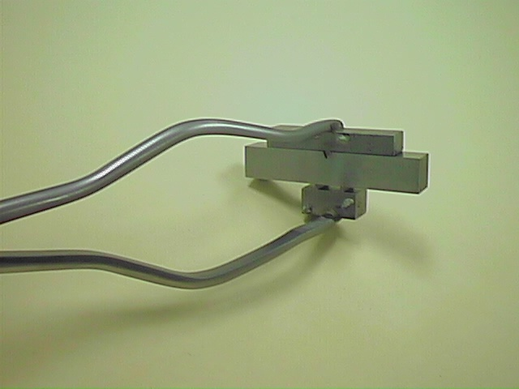
- Place the Charpy test specimen

3.1 Place a Charpy specimen in the tongs, aligning
the cut of the specimen with the protrusion
of the tongs. (see Figure 3)

3.2 Place the specimen on the anvil of the impact
tester, while ensuring that the notch faces
away from the hammer. (see Figure 4) Figure 3. Specimen in tongs

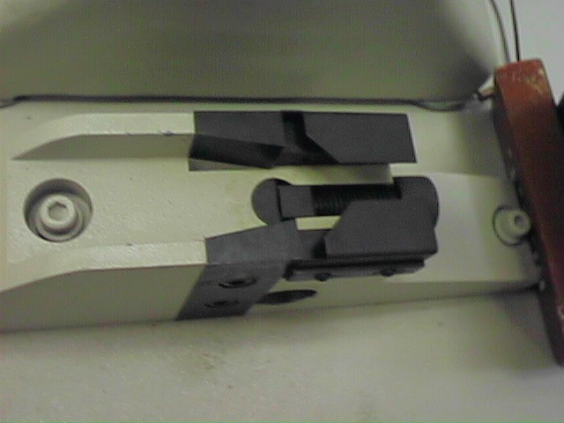
3.3 Once the specimen is on the anvil, hold down
the specimen with one finger and remove the
tongs by slowly releasing the pressure on the tongs.
(V-notch on specimen faces this direction)

place specimen here

Figure 4. Mount and anvil

- Raise the hammer into position
(see Figure 5a and Figure 5b) operator 1 operator 2

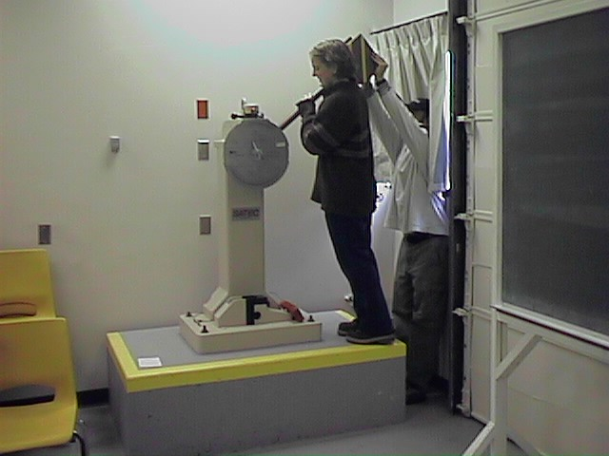
4.1 Operator 1: position yourself on the concrete pedestal
in front of the hammer.
Operator 2: position yourself at floor level behind the
hammer.

4.2 Both Operators: make sure that no part of your person
will be in the way of the swinging hammer.

4.3 Operator 1: grab the shaft of the hammer with both hands
and raise the hammer about 90 degrees, and then …

4.4 Operator 2: (behind the hammer) push up with both hands,
and then …

4.5 Both Operators: keep forcing the hammer upward until it Figure 5a. Operator positions
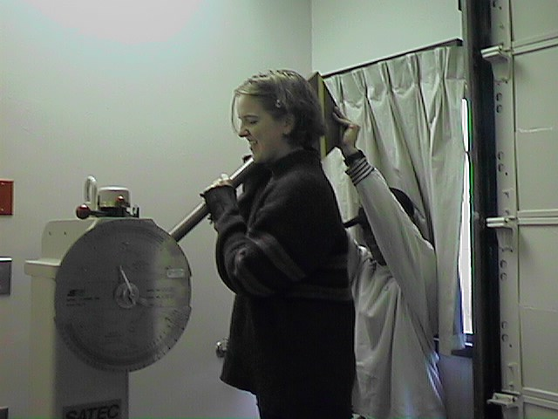
clicks into position, about 170 degrees from its original
position. (See Figure 5b)

Figure 5b. The hammer is
near its locked
position

Instructions: Charpy impact test, page 3

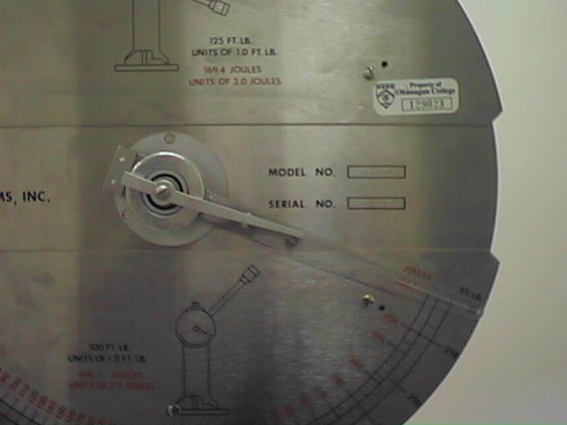
- Release and re-secure the specimen hammer

5.1 Position yourself in front of the impact tester,
facing the dial indicator.

5.2 Remove the safety block.

5.3 Adjust the energy indicator to 300 ft-lbs
(or 406.7 Joules), the hammer’s maximum
potential. (as in Figure 6)

Figure 6. Dial indicator

Caution:
Make sure that no one is in the path that the swinging hammer is about to take

5.4 Using your right hand, strike the handle against the pin and let the hammer swing one full
cycle (back and forth).

5.5 Lift the safety pin and push the handle into the brake position. (see Figure 1)

5.6 Put the pin back into its original position. (see Figure 1)

- Read the energy value

6.1 Read the dial indicator position, which indicates the actual energy absorbed by sample A,
and record both the ft. lbs. and Joules readings indicated for sample A.

Repeat steps 1.1 through 6.1 for the other three samples.

